**File Organization**

Sequential File Organization:

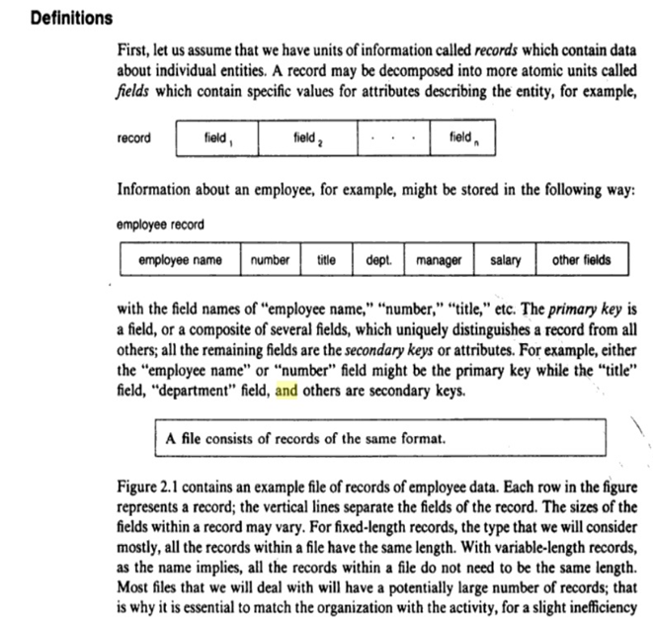

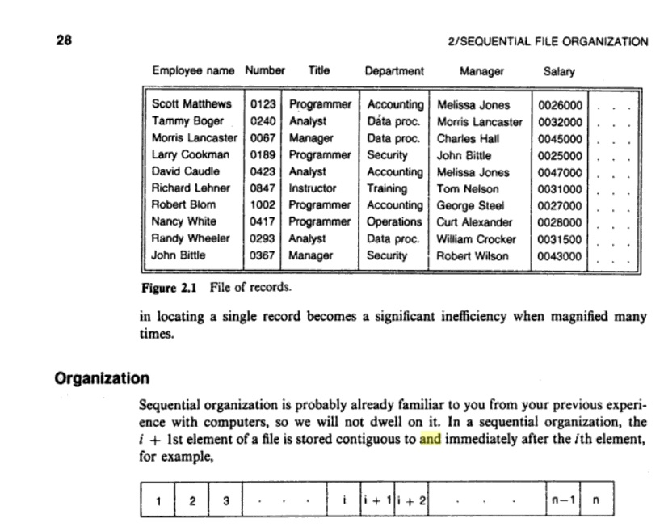

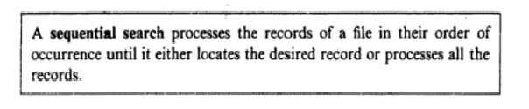

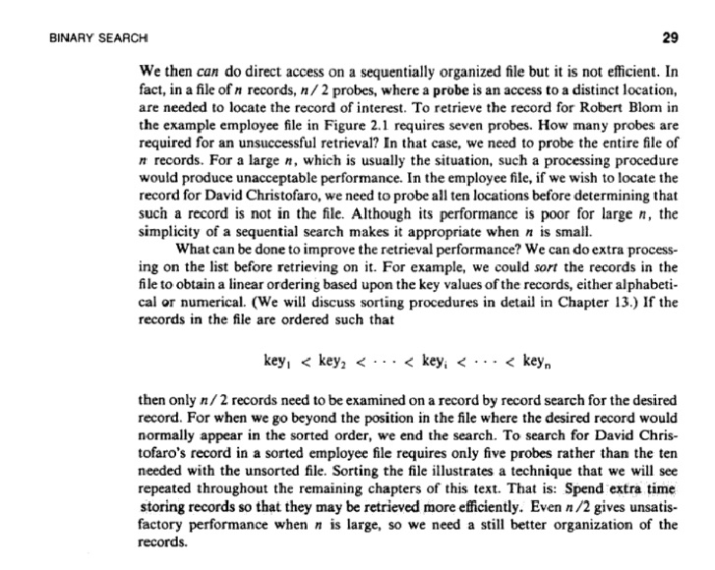

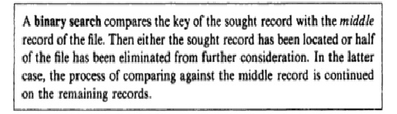

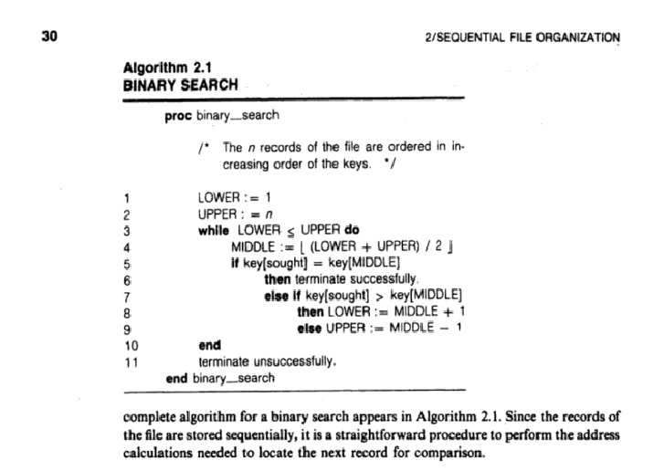

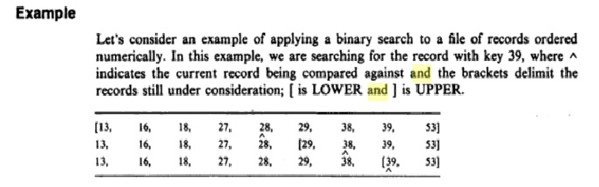

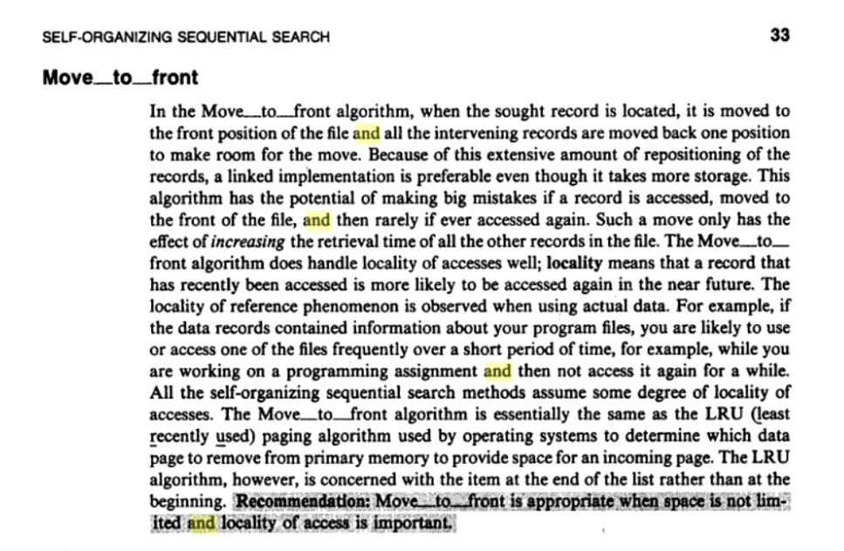

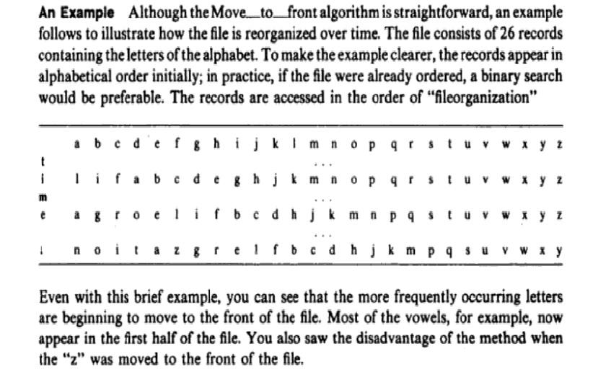

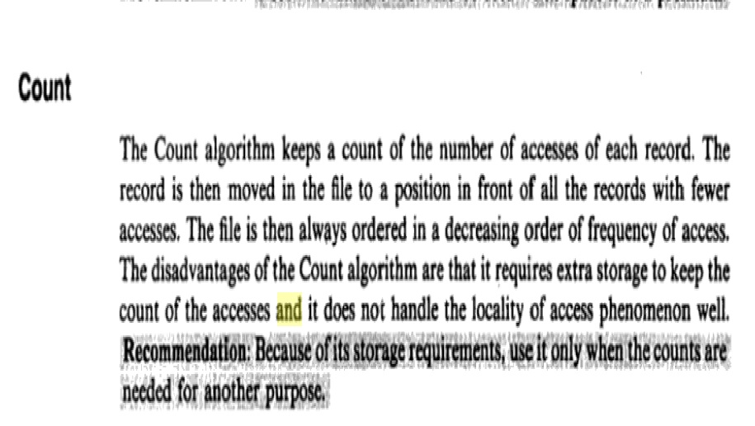

**Direct File Organization**

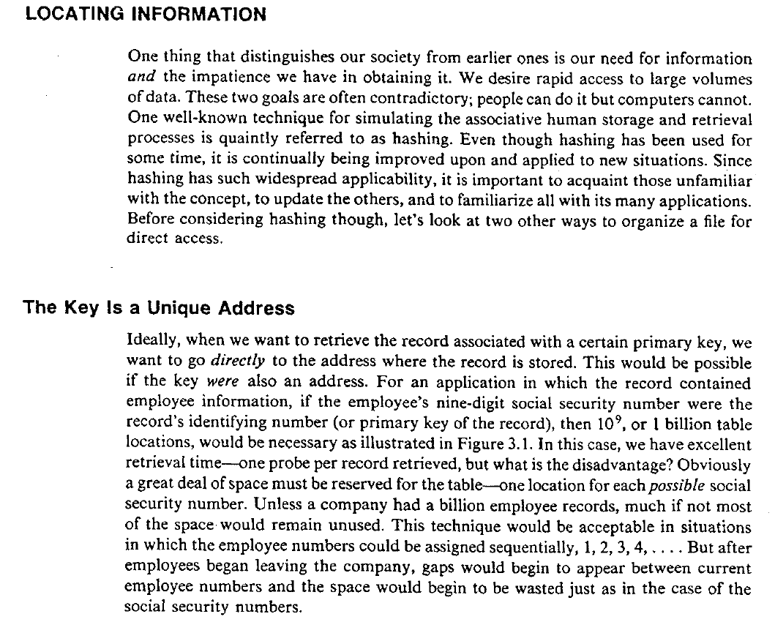

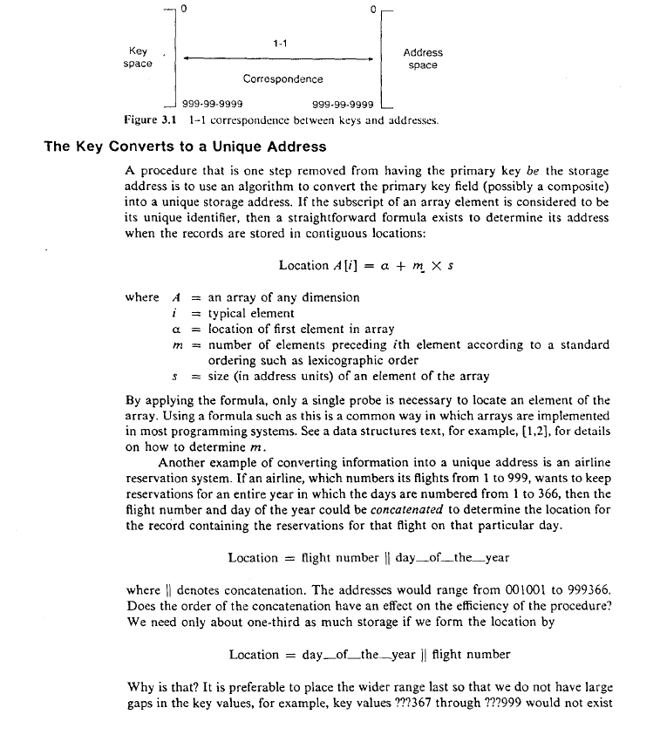

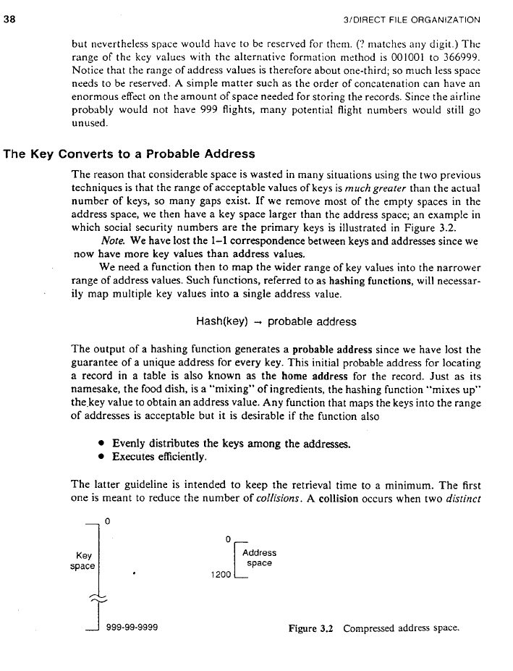

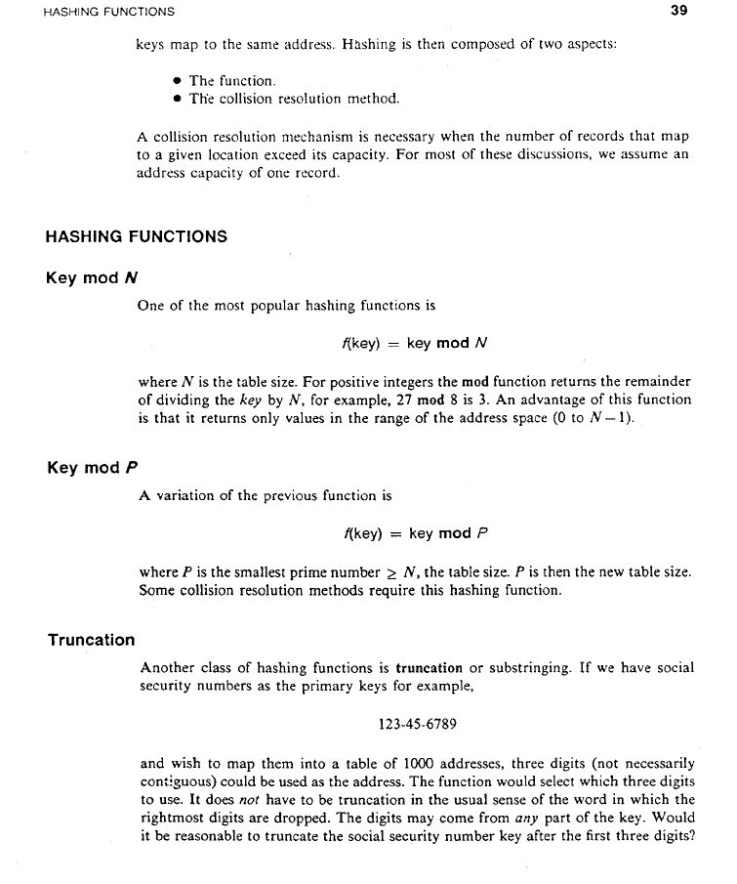

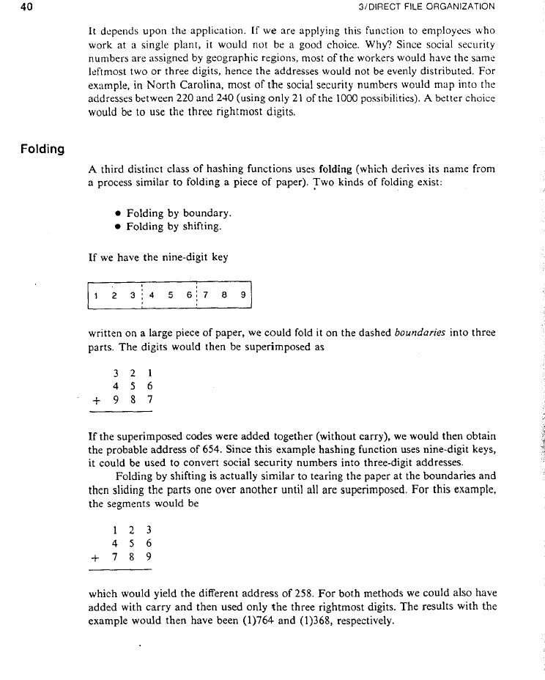

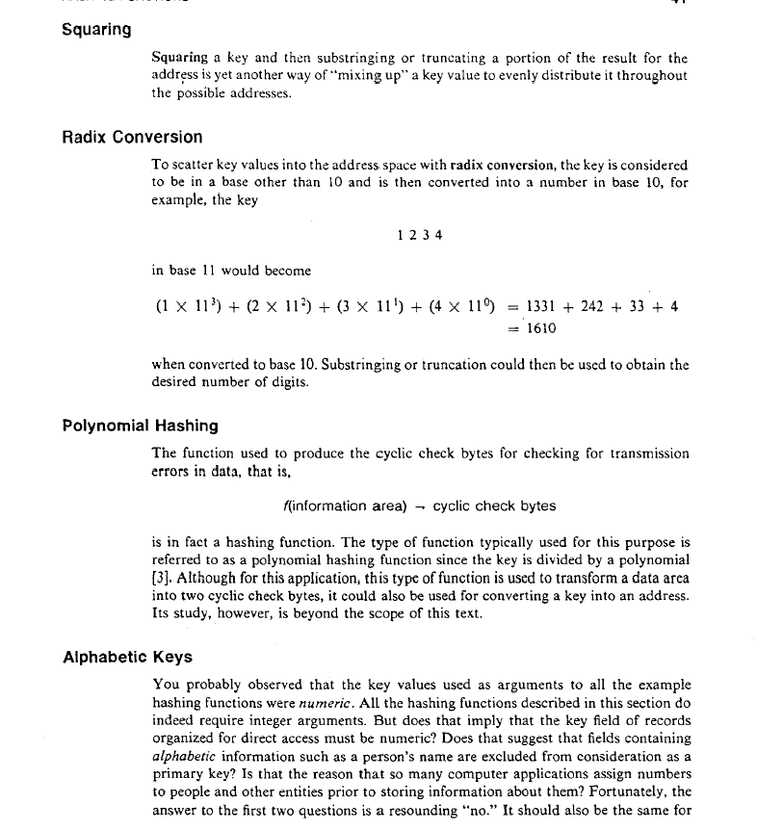

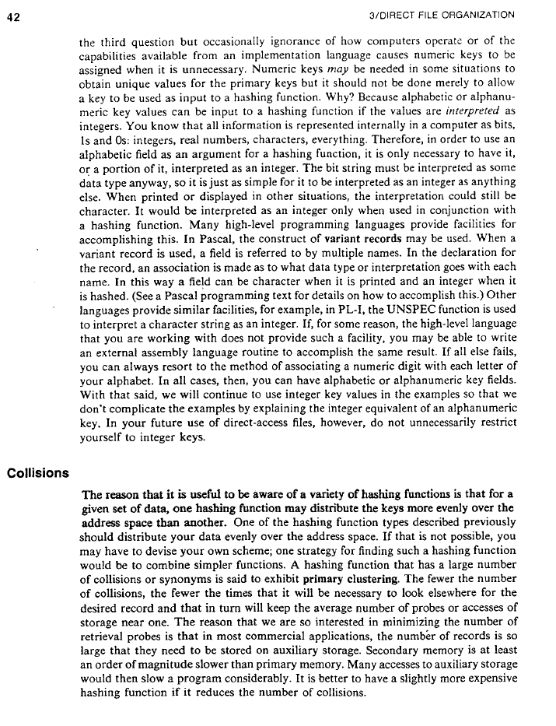

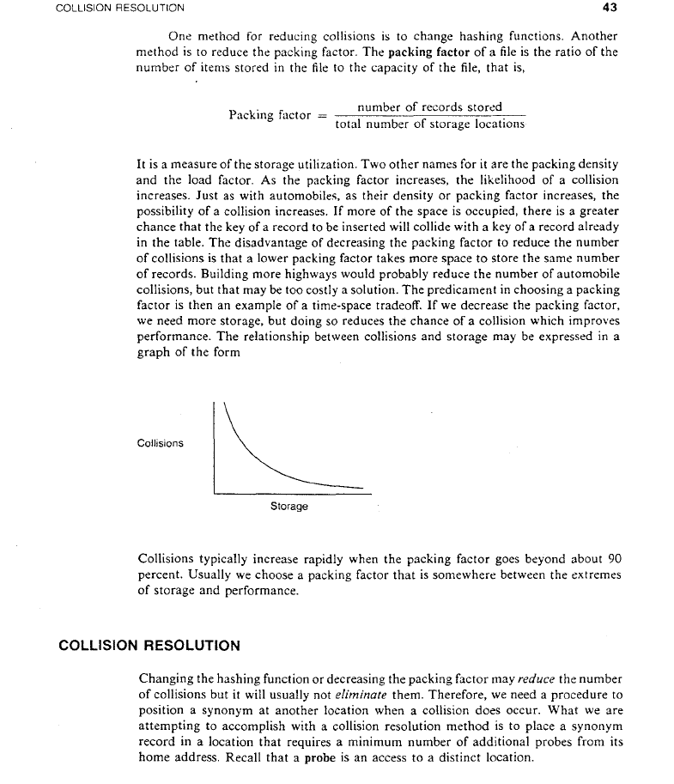

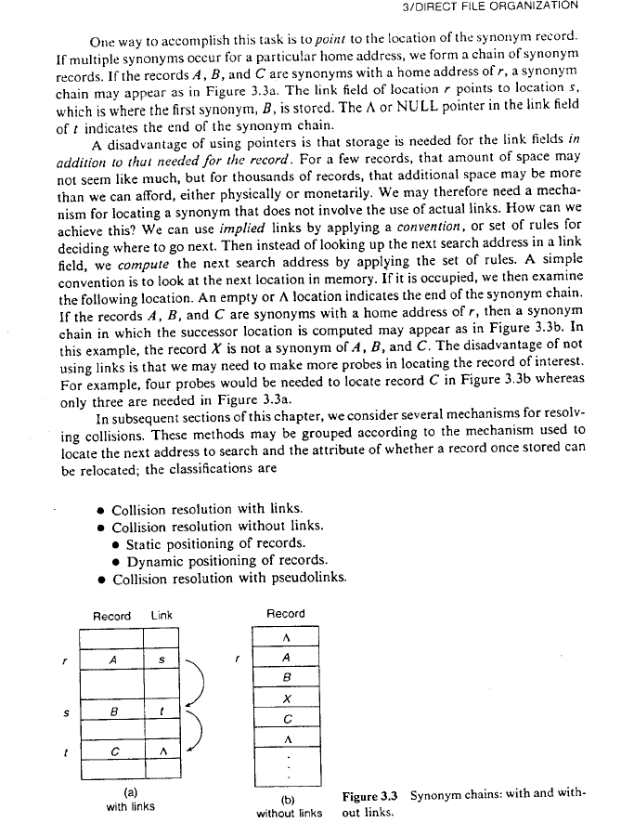

**Indexed Sequential File Organization**

🡪It is a combination of sequential file organization and direct file organization.

🡪It is advanced Sequential file organization

🡪We are adding extra information that is index. We are improving sequential file organization

🡪Intially we are arranging the records in sequentially next we are arranging Index values.

🡪It will reduce the numberof comparisons when compare to the sequential file organization

File

|  |  |  |  |  |  |  |  |  |  |  |  |  |  |  |  |
| --- | --- | --- | --- | --- | --- | --- | --- | --- | --- | --- | --- | --- | --- | --- | --- |
| 5 | 10 | 15 | 20 | 23 | 25 | 27 | 30 | 35 | 50 | 55 | 70 | 75 | 100 | 110 | 150 |

20 70

(Lower Index) (Lower Index)

30 150

(Higher Index) (Higher Index)

here searching value is 23, Initially we have to compare higher index. 30<23(condition false), so ,left side lower index is 20, Now we have to compare with left side lower index.Now 20<23, so consider right side elements. Searching value should be between two indexes only.So compare between 20-30 only. After lower index 20, next 23 will come. If you are following sequential access file organization total probe value is 5.Now Probe value is 3.

Next example is 110. First initially compare with higher index 30, 30<110, next we have to go right side that is 70<110, next 150<10, so condition is false.Now value is between 70 to 150 only. Next Searching started from 70, so we can find out 110.

If you want to update any values through Indexed sequential File Organization the above technique follows.

Example : Here consider student details file. for example take student-details file. In this file contains, serial number,sname ,sbranch and saddress.

|  |  |  |  |
| --- | --- | --- | --- |
| S.NO | SName | Sbranch | Saddress |
| 501 | A | CSE | PDTR |
| 502 | B | CSE | JMD |
| 503 | C | CSE | KDP |
| 504 | D | CSE | YGL |
| 505 | E | CSE | PDTR |
| 506 | F | CSE | MYD |

If I want to change 503 student values, initially you have to consider 505 index, so 505<503(condition false) goto left side.In the left side 502<503(condition true),next we have to compare (503==503), Record find. So now, we can change any value.

**Advantages of Indexed sequential access file organization:**

* In indexed sequential access file, sequential file and random file access is possible.
* It accesses the records very fast if the index table is properly organized.
* The records can be inserted in the middle of the file.
* It provides quick access for sequential and direct processing.
* It reduces the degree of the sequential search.

**Disadvantages of Indexed sequential access file organization:**

* Indexed sequential access file requires unique keys and periodic reorganization.
* Indexed sequential access file takes longer time to search the index for the data access or retrieval.
* It requires more storage space.
* It is expensive because it requires special software.
* It is less efficient in the use of storage space as compared to other file organizations.